The wildfire detection was realized through the use of a DenseNet-based classification network model consisting of three dense blocks and two transition layers to identify the fire with 224 × 224-pixel-size image inputs. The architecture of the simple network is illustrated in Figure 7. The dense block included a two-kernel filter. One filter was a 1 × 1 size convolution, which was used to decrease the number of input feature map channels, and the other was a 3 × 3 size convolution. After the dense block, the feature maps passed through a phase layer consisting of batch normalization, ReLU, 1 × 1 convergence, and 2 × 2 average pooling, which reduced the width and length of the feature map and the number of feature maps. Finally, after three dense block sessions, the result was drawn Remote Sens. 2020, 12, 3715 8 of 16 after the linear layer at the end, after passing through the global average pooling and softmax classifier sequentially, as in the case of a traditional CNN. Figure 6. Sample of the wildfire images converted from non-fire mountain images. 3.2. Wildfire Detection The wildfire detection was realized through the use of a DenseNet-based classification network model consisting of three dense blocks and two transition layers to identify the fire with 224 × 224-pixel-size image inputs. The architecture of the simple network is illustrated in Figure7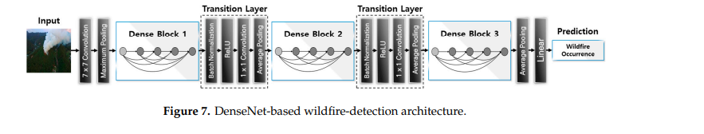

. DenseNet-based wildfire-detection architecture. DenseNet-based wildfire-detection architecture. The following section presents the results of the wildfire-detection performance obtained using the deep learning classification model based on DenseNet, as compared to the pre-trained model. Two results were derived for each model—one for train set A and the other for train set B